Name Abdull Haseeb

SU92-BSAIM-F24-050

BSAI-3A

AI LAB TASK 2

Mini project 1:

**📝 Title: FizzBuzz Program Documentation**

**1. Objective**  
The aim of this task is to create a program that plays the classic FizzBuzz game. The program prints numbers from 1 to 100 with the following rules:

* Print **"Fizz"** if the number is divisible by 3.
* Print **"Buzz"** if the number is divisible by 5.
* Print **"FizzBuzz"** if the number is divisible by both 3 and 5.
* Otherwise, print the number itself.

**2. Tools Used**

* Programming Language: Python
* Concepts: Loop (for), Conditional statements (if-elif-else), Modulo operator (%).

**3. Working Principle**

* The program runs a loop from 1 to 100.
* For each number, the divisibility is checked using the modulo operator.
* Depending on the condition, the output is decided.

**4. Sample Output (First 15 Results)**

1

2

Fizz

4

Buzz

Fizz

7

8

Fizz

Buzz

11

Fizz

13

14

FizzBuzz

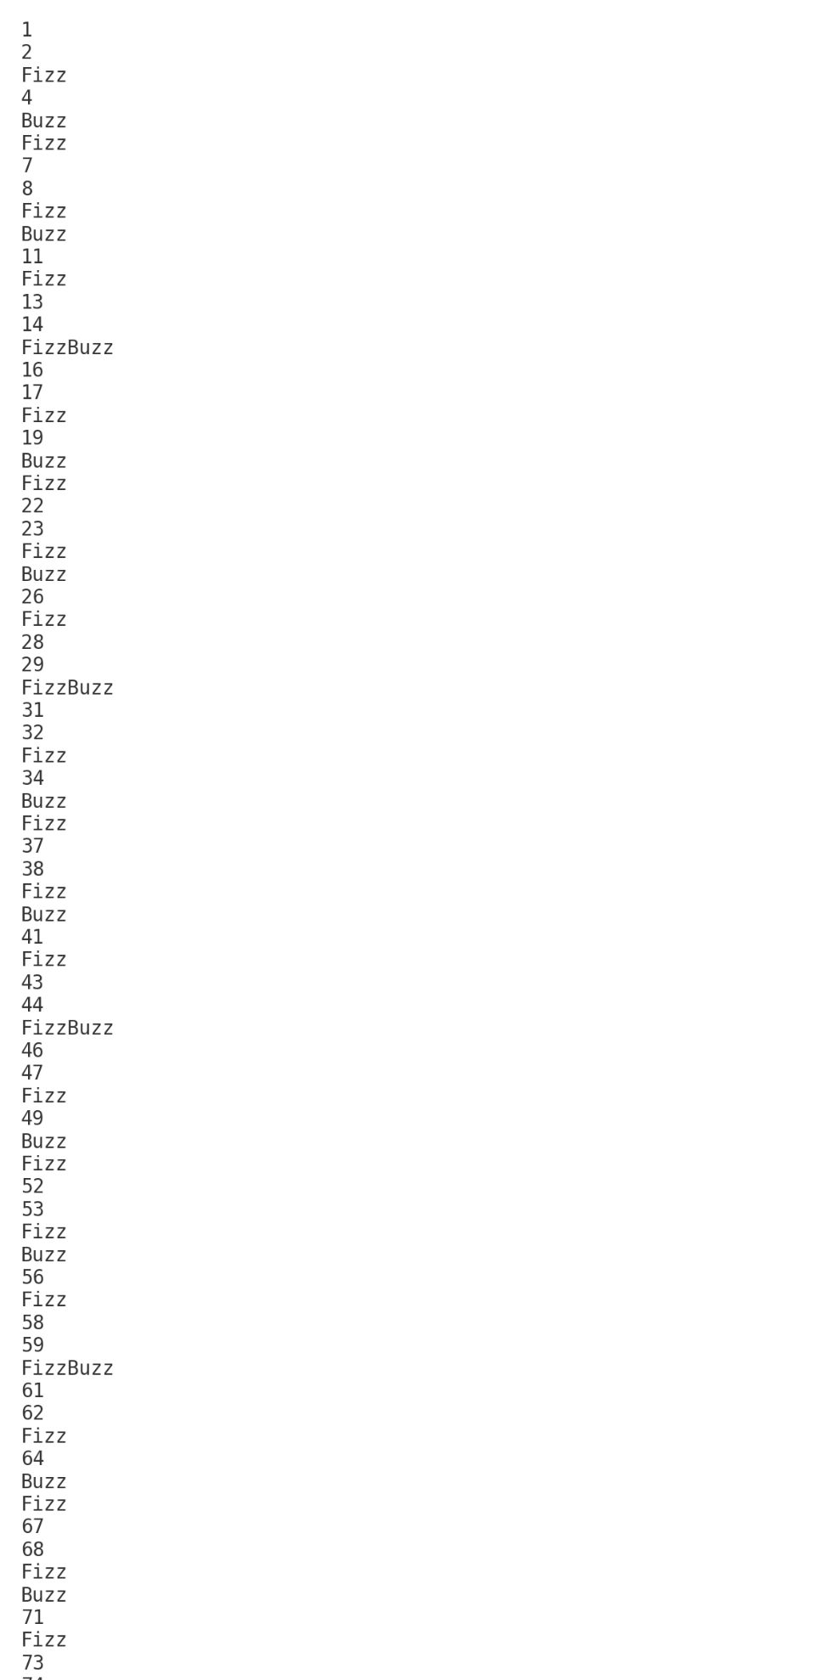

**5. Conclusion**  
This project demonstrates the use of basic programming concepts such as loops, conditions, and arithmetic operators. The program successfully generates the FizzBuzz sequence from 1 to 100.

Mini project 2:

**📄 Mini Project 2 – Movie Budget Analysis**

**Objective**

The purpose of this project is to analyze the budgets of a given set of movies. The program calculates the average budget of all movies and identifies which movies have budgets higher than the average. It also counts how many movies exceeded the average budget.

Additionally, the program allows users to add more movies to the dataset before running the analysis.

**Dataset**

The dataset consists of a list of movies, where each movie is represented by two values:

1. **Movie name** (string)
2. **Movie budget** (integer in US dollars)

Example:  
("Inception", 160000000)

**Steps Performed**

**1. Adding New Movies**

* The program first asks the user how many movies they want to add.
* For each new movie, the user enters:
  + The name of the movie
  + The budget of the movie

These movies are added to the existing dataset.

**2. Calculating Average Budget**

* The program adds up the budgets of all movies.
* The total is divided by the number of movies.
* This gives the **average movie budget**.

Formula:

Average Budget=Sum of All BudgetsNumber of Movies\text{Average Budget} = \frac{\text{Sum of All Budgets}}{\text{Number of Movies}}

**3. Identifying High-Budget Movies**

* The program compares each movie’s budget with the average budget.
* If a movie’s budget is higher than the average:
  + It prints the movie name
  + It prints how much higher its budget is compared to the average

**4. Counting High-Budget Movies**

* The program keeps a counter of how many movies are above the average.
* Finally, it prints this total count.

**Output Example**

If no movies are added, the program might produce output like this:

* **Average budget** = 190,428,571
* Movies above average:
  + Pirates of the Caribbean: On Stranger Tides → $379,000,000
  + Avengers: Age of Ultron → $365,000,000
  + Avengers: Endgame → $356,000,000
  + Incredibles 2 → $200,000,000
* **Total movies above average** = 4
* Average budget = 190500000.0
* Pirates of the Caribbean: On Stranger Tides budget = 379000000 which is 188500000.0 higher than average
* Avengers: Age of Ultron budget = 365000000 which is 174500000.0 higher than average
* Avengers: Endgame budget = 356000000 which is 165500000.0 higher than average
* Incredibles 2 budget = 200000000 which is 9500000.0 higher than average
* Total movies above average: 4